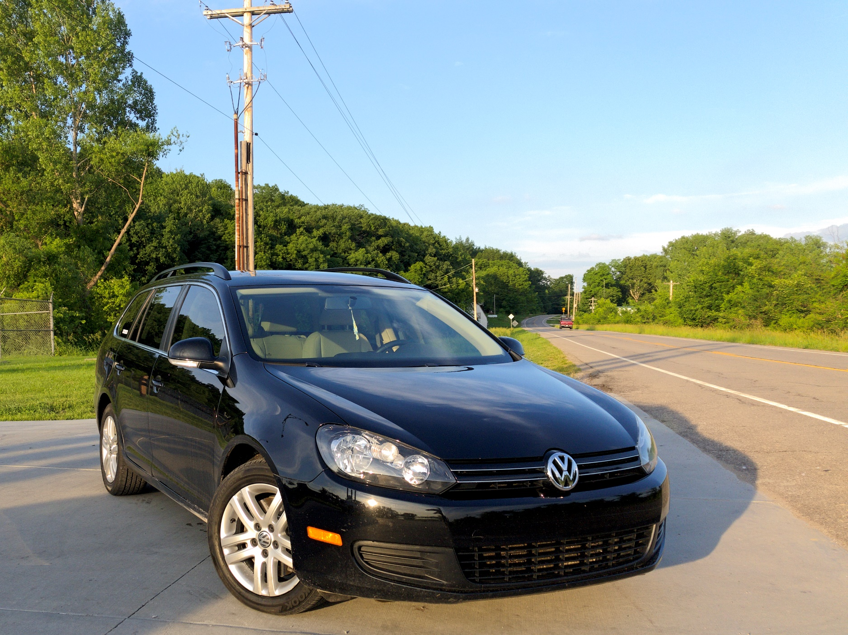Kinship of the Jetta, Deserving

By [David Blue](https://twitter.com/NeoYokel)

## In my newfound humility, I bear the marque of the common man, but is it a punishment?

I had the privilege of spending nearly a year with a 2014 Volkswagen Jetta TDI Sportwagen through a brief period of two-hour, both way commuting, a half-year (quite interesting) stint in ridesharing, and my usual country road-bombing shenanigans. In acquiring it, my plan - and it was a good plan - was to cease an era of general insensibility in my life's decisions by entombing my wayward self within the most sensible expression of modern automotive design I suspected I could live with. According to [a Tweet](https://twitter.com/NeoYokel/status/261163556073005056) from October, 2012 (which I did not consciously remember at the time of purchase,) I had long considered Jetta Wagon ownership. The wagon component, then, was long established, but some casual research added diesel power and manual transmission. Diesel, manual, wagon - of the people's car, these I sought. Nay, *demanded*.

American car buyers do not like diesels, wagons, or manual transmissions. Folks like me seem to have [quite an affinity](https://www.nytimes.com/2013/10/20/automobiles/autoreviews/diesel-wagon-whatll-they-think-of-next.html) for all of these, so a culmination of all three into a single product should be very desirable, in theory.

Auto writers have long tooted the horn about the benefits of diesel engines, and a bunch of them have also argued that the old-school station wagon is a far more efficient way to haul things around than a bloated high-set S.U.V.

Surprisingly, I only needed to pass up a single option in the Kansas City area before I found The One: a 2014 post-[Dieselgate](https://youtu.be/SvokGhOaHGg) example with ~65,000 miles on its odometer in “Deep Black Pearl” with a “Cornsilk Beige” interior which had been previously owned only by a single Michigan cyclist. My salesman Charles likely noted that my friend, girlfriend, and I were (and are) entirely unafraid of facing The End when a very near collision during our test drive did not perturb us in the least, but left him huffing and puffing from adrenaline. He was a star, though, throughout the more than four hours of deliberations required for his institution to reckon with my credit history. Eventually, I ended up spending almost exactly $12,000, which was probably too much, and named my new automobile Martin - "Marty" for short - after Martin Winterkorn, the former CEO of Volkswagen AG who [bore more than his share of the blame](https://www.bloomberg.com/news/articles/2018-05-03/ex-vw-ceo-winterkorn-charged-by-u-s-in-diesel-cheating-case) for Dieselgate, including [charges of fraud](https://www.theverge.com/2019/4/16/18369528/vw-ceo-martin-winterkorn-dieselgate-germany-volkswagen-emissions-scandal) by the German government. *Dirty diesel rolling coal in prison*.

By "post-Dieselgate," I mean that my new car was a part of [Volkwagen's $10 billion buyback program](https://www.caranddriver.com/news/a15344947/whats-volkswagen-doing-with-all-those-repurchased-diesels/), so the Michigander sold it back to the manufacturer for its "fair replacement value" - [between $12,500 and $44,000](https://www.caranddriver.com/news/a15347930/volkswagen-settles-diesel-emissions-violations-for-14-7-billion-even-more-fines-to-come/) according to *Car & Driver* on behalf of FTC chairwoman Edith Ramirez. If I thought you were interested, I would attempt to detail [exactly what my car was then subjected to](https://www.caranddriver.com/news/a15351089/volkswagen-details-fix-for-ea189-diesel-in-europe-but-itll-be-more-complex-for-u-s) by a dealer, but suffice it to say that it was made less fuel efficient and a bit less powerful, to my chagrin. Still, even my first encounter with Martin was inundated with plenty of torque from its venerable 2.0L [EA189/CJAA](https://www.motorreviewer.com/engine.php?engine_id=43) turbodiesel four-cylinder. In original spec, 236 lb.-ft. of it arrived between 1750-2800 RPM, but my (admittedly, unscientific) perception indicates that post-update, the torque was coming a bit later. How much of it was left, I cannot tell you, but it was certainly enough to spin the front wheels in first gear with *any* accelerator aggression in dry conditions. In the wet, second and third yielded slip from the shitty tires with which Martin was equipped when I bought him.

At the time of purchase, I was living in Liberty, MO – a sort of subdivision of Kansas City – in a little house with my co-worker and friend. I’d been depending on him and his Wrangler to carry me around for months (thanks, Jack,) so it was particularly freeing to have my own automobile again. (The last car I’d owned was an [old Lincoln](https://www.instagram.com/p/BiYABpKAJQX/) in Portland, in which I briefly lived.) Martin became a vehicle for a rediscovery and newfound appreciation for my Missouri home – the great Missouri River, especially. Not since owning my Miata had I driven so much in the country. My girlfriend and I [visited Cooper’s Landing](https://www.instagram.com/p/BuP3y62laon/) in the wet and ventured down to Springfield, Missouri (very far South,) near which we discovered [Hodges Speedway](https://dieselgoth.com/race-day-at-hodges) – a [then-abandoned dirt oval](https://www.facebook.com/AsphaltApostle/videos/10218812861450693) surrounded by demolition derby casualties and the large trucks used to haul them around.

Somewhere North of Kansas City, I opened the taps all the way on a very long straight and reached 125mph, which is either the aerodynamic VMax, an electronically limited limit, or both. Surprisingly, the modern people’s car feels quite stable at this speed – were it not my own automobile, I’m not sure I wouldn’t just travel this fast everywhere. In the past few years, Interstate 70 – which cuts Missouri just about in half from West-East, connecting St. Louis and Kansas City with my hometown in the center – has become significantly faster-paced than I remembered it before moving to Portland for two years. 80mph used to be the accepted number, 70 (the actual speed limit) was the unenforced minimum. In my old Toyota pickup, I could travel at 65 without attracting too much criticism. *Now*, however, one must maintain 85 to keep up with traffic, especially when traveling with commuters. 90-95 will no longer garner judgmental looks and 100mph left-laners are given a pass.

“I’ll bet that’s great on the highway” is probably the most regular comment received from passersby and riders right after “is this a diesel!?” (Really, the fact of my Jetta’s existence as a manual-equipped diesel wagon seemed to utterly astound a great many people.) There is truth in this general supposition: the ability of the diesel powerplant to deliver hill-climbing torque at low RPM is simply unmatched by gasoline powerplants of the same displacement, which means that “highway” driving entails virtually zero downshifting – arrive in sixth gear, set the cruise control, take a nap. Everything else is taken care of. There is a definite luxury in the knowledge that one is no longer needed in the process at speed – luxury that is NOT present in a gasoline-to-manual Jetta drivetrain. From [*Hackaday*](https://hackaday.com/2019/09/26/the-future-of-diesel-is-on-shaky-ground/):

[Diesel] has a higher volumetric energy density than gasoline, and thanks to low volatility, diesel engines can run at significantly higher compression ratios without risking detonation. These benefits allow diesel engines to produce significantly more torque than similarly sized gasoline engines.

“Diesel engines are typically poor when it comes to power to weight ratio, as their high compression ratio and torque output demands heavier materials in their construction,” notes Lewin Day, meaning *steel* engine block. Here we arrive on my singular dissatisfaction with the Jetta: **its weight**. While traveling from Kansas City back home in the East one day, I decided to satisfy a longtime bucketlist item and stop by a weigh station. As I drove up to the scale, the police-uniformed attendant looked up at me from his glass box and gave [the standard white guy smile frown](https://twitter.com/rashadpls/status/650114296937058304). It took a moment for the scale to register Martin, but it eventually displayed a whole **3440** **lbs**. My little “compact” wagon… weighed significantly more than one and three-quarter tons – just 528 lbs. less than the [full-sized, supercharged V8-powered Jaguar saloon car](https://www.instagram.com/p/BJPe6rWAcnr/) I call the automotive love of my life, and almost a full 200 lbs. more than [its GLI sedan sibling](https://www.caranddriver.com/reviews/a15129379/2011-volkswagen-jetta-gli-20-tsi-review/).

After discovering this figure, I did what I could to diminish the weight easily without tearing into the seats or removing some of the car’s *fourteen* airbags. Upon lifting up the base of the “car-go” area in the rear, I found a *full* steel spare wheel – some 30 lbs of it at least – which I immediately removed, along with some sort of flapping cargo restraint that I can only suspect was designed to keep objects (like dogs, perhaps) in the cargo area from sailing into the passenger compartment during an accident. Ideally, I intended to one day strip out all of the interior except for the driver’s side chair, but it ‘twas not intended to be.

## [Modified Jetta TDI Sportwagen - One Take](https://www.youtube.com/embed/x3HwWn55MJY?feature=oembed)Performance

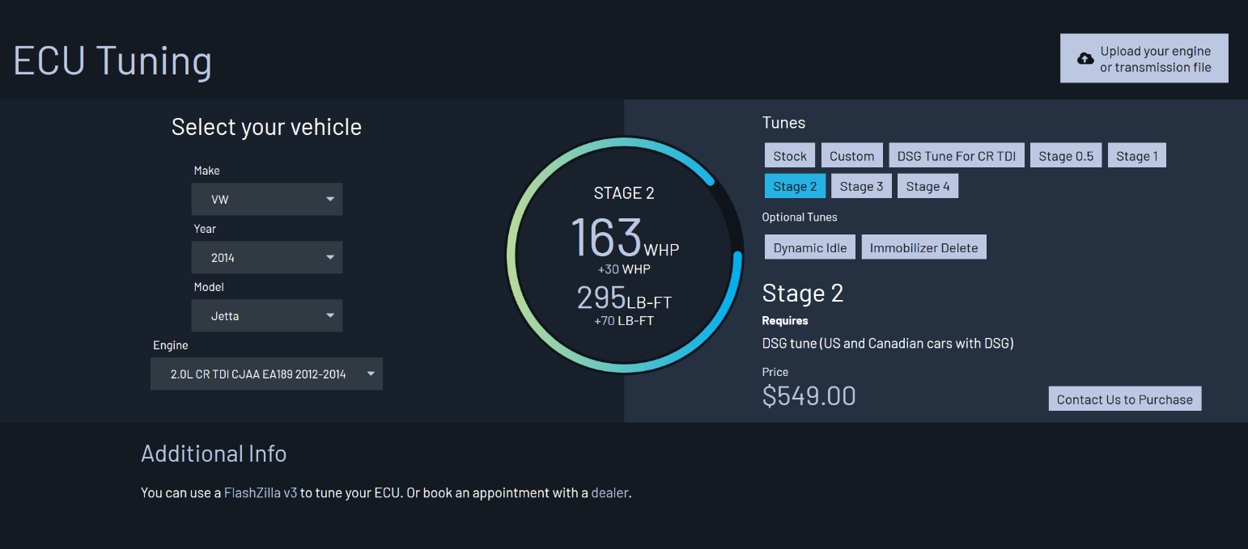For the first time in my personal automotive history, I felt the desire to modify one of my own cars. I found myself on Facebook for the first time in ages joining Groups like [TDI Scumbags](https://www.facebook.com/groups/173989949914106), [VW TDI Owners](https://www.facebook.com/groups/24097854515), and [VW TDI Owners Performance and Tech Talk](https://www.facebook.com/groups/2501785479863909). I even [filmed myself](https://www.instagram.com/tv/ByJ3-u4luhV65nfvVjZ94z00WOTjImro12LtXw0/) calling it my “rally Sportwagen project,” whilst talking about my “shift boot delete” (I cut the leather around the shift lever off because I despised the way it made gear changes feel,) and my “spare wheel delete” (for weight saving’s sake.) Perhaps the most famous appearance of the Jetta Sportwagen in the modern era was driving instructor Austin Cabot’s 2014 Sportwagen in [one of Matt Farah’s infamous *One-Take*s](https://youtu.be/x3HwWn55MJY). You can find the full list of modifications on [the car’s *WheelWell* page](https://www.wheelwell.com/austin-cabot/im7/2014-volkswagen-jetta-sportwagen). I intended to emulate Austin with a few modifications including Dieselgeek’s [Sigma 6 shortshift kit](https://www.dieselgeek.com/collections/vw-short-shifters/products/sigma-6-six-speed-short-shift-kit-for-vw) and “high performance” [shifter bushing kit](https://www.dieselgeek.com/products/high-performance-vw-shifter-shaft-bushings-for-mk4-golf-jetta-new-beetle?variant=6292541866027) (which I did get around to buying, but never installed.) For those interested in engine/ECU tuning, Malone Tuning has a [beautiful tool](https://malonetuning.com/ecu-tuning/VW/2014/Jetta/2.0L-CR-TDI-CJAA-EA189-2012-2014/Stock) to help you customize your order.

I spent far more consecutive time in my Jetta than I have in any other automobile – after spending two years driving an old Lincoln – so my sense of its driving dynamics is likely quite skewed, but I thoroughly enjoyed the experience at the limit, which wasn’t altogether hard to find. Unfortunately, I never got around to installing ECS Tuning’s [Traction Control button retrofit](https://www.ecstuning.com/b-ecs-parts/traction-control-button-retrofit-kit-without-keyless-start/003208ecs01kt/), which I suspect would have enabled significantly more impishness than I was able to find possible.

As Mark Gillies puts it [for *Car & Driver*](https://www.caranddriver.com/reviews/a15125011/volkswagen-jetta-review-2011-vw-jetta-drive/):

Wind, tire, and engine noise are muted, the ride is well controlled and damped, and the steering builds effort in a nicely linear fashion, even if on-center feel is largely AWOL. Our biggest dynamic complaint is the omnipresent stability control, which rushes in to kill the fun and can’t be switched off. It’s a pity, because the chassis is responsive and nicely balanced.

There’s something about the torque that becomes truly intoxicating, which – I know – is not a word you’d expect to hear regarding The People’s Car.

### Efficiency

Average: **29.84** mpg  
Total Gallons Pumped: **644**  
Total Spent: $**1726.94**  
Total Miles Driven: **19506**

According to my [fuel logs](https://eileenlong-my.sharepoint.com/:x:/g/personal/david_eileenlonglcsw_com/EbMIF1pW62JDu3pb4NnCzZoBg_FWIzo_Z48lyGM9oi-VSA), (they are public, yes, though not necessarily 100% complete,) I averaged close to 30 mpg over 78 fillups and just over 19500 miles. Considering that I was ridesharing most of that time and driving quite obnoxiously for all of it, you should be very impressed. “Diesels tend to get about 30-percent better fuel economy than their conventional counterparts,” says *Consumer Reports* in a [comparison between diesels and hybrids](https://www.consumerreports.org/cro/news/2013/10/diesel-offer-great-highway-fuel-economy/index.htm) dating back to 2013. From the [*Union of Concerned Scientists*](https://blog.ucsusa.org/dave-cooke/diesel-vs-hybrid-cost-benefits-410):

Much of the reason for diesel vehicle’s high fuel economy has to do with the diesel combustion process; however, some of the increase in fuel economy is due to the simple fact that a gallon of diesel fuel contains more energy than a gallon of gasoline.

## Quality

Over the course of the Jetta’s history, Volkswagen has struggled to determine where it should be in the market. In his [first review of the Mk. VI Jetta](https://www.caranddriver.com/reviews/a15129377/volkswagen-jetta-review-2011-volkswagen-jetta-first-drive/) in 2011, Tony Quiroga for *Car & Driver* looked back at the launch of its predecessor:

During the press launch of the outgoing Jetta back in 2005, Volkswagen touted that car as a less expensive alternative to an Acura TSX or Volvo S40. Volkswagen pointed to its growth in size, high-quality interior, new rear suspension, and refined demeanor as evidence that the Jetta had moved out of the Honda Civic and Toyota Corolla class.